Topics: Confidence Intervals

- For each of the following statements, indicate whether it is True/False. If false, explain why.

- The sample size of the survey should at least be a fixed percentage of the population size in order to produce representative results.
Ans: False
The sample size should be at least 30.

- The sampling frame is a list of every item that appears in a survey sample, including those that did not respond to questions.
Ans: False
The sampling frame is a list of all the items or elements that have a chance of being included in the survey sample. However, the sampling frame typically does not include those elements that did not respond to survey questions.

- Larger surveys convey a more accurate impression of the population than smaller surveys.
Ans : True

- PC Magazine asked all of its readers to participate in a survey of their satisfaction with different brands of electronics. In the 2004 survey, which was included in an issue of the magazine that year, more than 9000 readers rated the products on a scale from 1 to 10. The magazine reported that the average rating assigned by 225 readers to a Kodak compact digital camera was 7.5. For this product, identify the following:

- The population
Ans: The population in this scenario is all readers of PC Magazine who participated in the survey which is more than 9000.
- The parameter of interest
Ans: It is the average rating given by all readers in the population to the Kodak compact digital camera
- The sampling frame
Ans: The sampling frame would be all readers who participated in the survey.
- The sample size
Ans: Sample size is 225 readers.
- The sampling design
Ans: It is voluntary sampling design, where 225 readers were voluntarily responded for the survey.
- Any potential sources of bias or other problems with the survey or sample
Ans: It is possible that the rating provided by all the participant may not accurately reflect the opinion of the entire population. Some of the participants may have stronger feelings ( good or bad) about the product which may lead to bias response of the product.

- For each of the following statements, indicate whether it is True/False. If false, explain why.

- If the 95% confidence interval for the average purchase of customers at a department store is $50 to $110, then $100 is a plausible value for the population mean at this level of confidence.
Ans: True

- If the 95% confidence interval for the number of moviegoers who purchase concessions is 30% to 45%, this means that fewer than half of all moviegoers purchase concessions.
Ans: True

- The 95% Confidence-Interval for μ only applies if the sample data are nearly normally distributed.
Ans: False.
Sample data should be at least 30, the central limit theorem implies that the sampling distribution is normal regardless of the data itself.

- What are the chances that ?

- ¼
- ½
- ¾
- 1
Ans: B) 1/2

- In January 2005, a company that monitors Internet traffic (WebSideStory) reported that its sampling revealed that the Mozilla Firefox browser launched in 2004 had grabbed a 4.6% share of the market.

- If the sample were based on 2,000 users, could Microsoft conclude that Mozilla has a less than 5% share of the market?
Ans:
- Null Hypothesis (H0): Mozilla's market share is 5% or greater.
- Alternative Hypothesis (H1): Mozilla's market share is less than 5%.
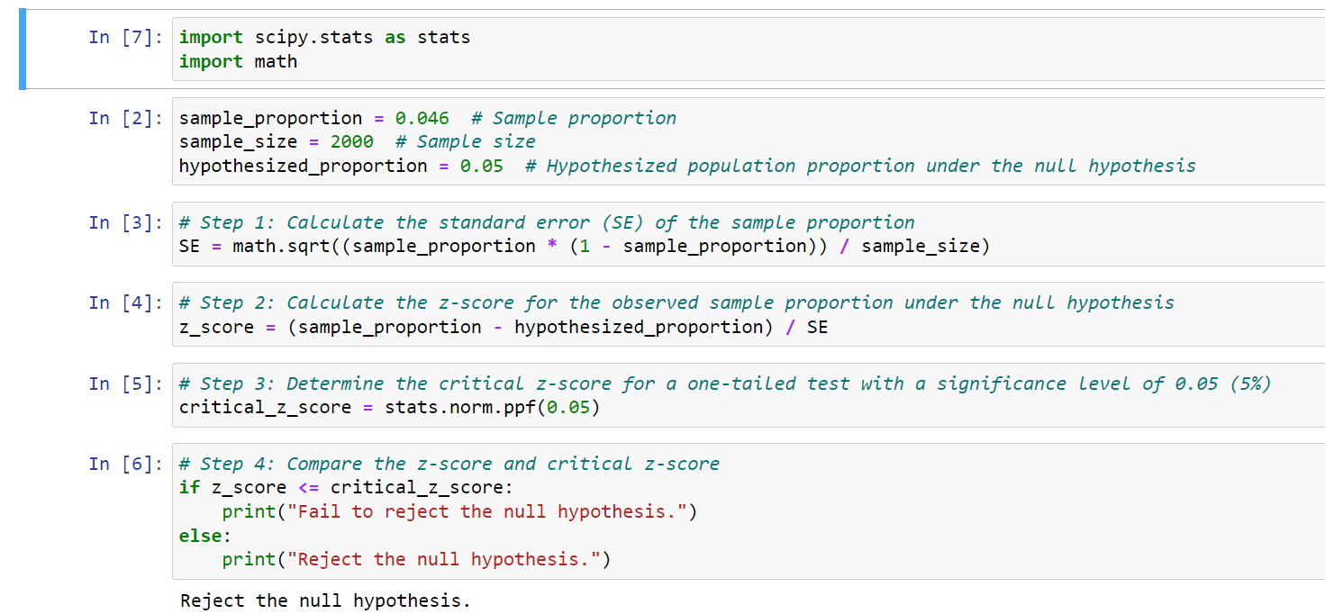

Here we reject the null hypothesis,
Therefore, Mozilla's market share is less than 5%.

- WebSideStory claims that its sample includes all the daily Internet users. If that’s the case, then can Microsoft conclude that Mozilla has a less than 5% share of the market?
Ans: If the data includes information from all daily Internet users and shows that Mozilla's market share is less than 5%, Microsoft can conclude that Mozilla has a less than 5% share of the market without relying on statistical tests.

- A book publisher monitors the size of shipments of its textbooks to university bookstores. For a sample of texts used at various schools, the 95% confidence interval for the size of the shipment was 250 ± 45 books. Which, if any, of the following interpretations of this interval are correct?

- All shipments are between 205 and 295 books. False

- 95% of shipments are between 205 and 295 books. False

- The procedure that produced this interval generates ranges that hold the population mean for 95% of samples. True

- If we get another sample, then we can be 95% sure that the mean of this second sample is between 205 and 295. False

- We can be 95% confident that the range 160 to 340 holds the population mean. False

- Which is shorter: a 95% z-interval or a 95% t-interval for μ if we know that σ =s?

- The z-interval is shorter
- The t-interval is shorter
- Both are equal
- We cannot say
Ans: Option (A) The z-interval is shorter

Questions 8 and 9 are based on the following: To prepare a report on the economy, analysts need to estimate the percentage of businesses that plan to hire additional employees in the next 60 days.

- How many randomly selected employers (minimum number) must we contact in order to guarantee a margin of error of no more than 4% (at 95% confidence)?

- 600
- 400
- 550
- 1000
Ans: For 95% confidence interval (z- score) = 1.96
n = z*2 * p *(1-p)/E*2
n= 1.96*2 * 0.5 *(1-0.5)/0.04*2 = 600.25
Therefore option D is correct.

- Suppose we want the above margin of error to be based on a 98% confidence level. What sample size (minimum) must we now use?

- 1000
- 757
- 848
- 543
Ans:
For 98% confidence interval (z- score) = 2.33
n = z*2 * p *(1-p)/E*2
n = 848.33
Therefore option C is correct.

